

**SWE 363: Web Engineering and Development**

**Final Report**

***KFUPMTrade***

**By:**

**Mohammed Alshehry, 201138010**

**Awad Aljuaid, 201161930**

Table of Contents

1. Introduction 3

2. Requirement Specification and Design 3

2.1 Use Case Model 3

2.2 Class Diagram 3

2.3 Navigation Model 3

2.4 Presentation Model 3

2.5 Statecharts and interaction diagrams 4

2.6 Activity Diagrams for Task Modeling 4

3. Application Architecture 4

4. Implementation Details 4

4.1 Technologies and Tools 4

4.2 GUI Screen Shots 4

4.3 Source Code 4

4.4 Open source code reusability 5

5. Conclusion 5

6. Worksheet 5

# Introduction

KFUPMTrade is a simple online market. The objective of this web application is to enable sellers to advertise for their products and services. Also, it enables users to find them.

# Requirement Specification and Design

Provide requirements and design diagrams used to specify your application (Not all diagrams are required)

## Use Case Model

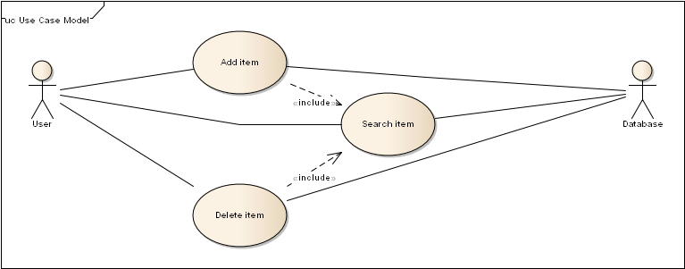

## Class Diagram

Provide the class diagrams for conceptual modeling. Use the stereotyped class diagram for Navigation.

## Navigation Model

Provide the navigation model for your application

## Presentation Model

Provide the presentation model for your application

## Statecharts and interaction diagrams

Provide statecharts and interaction diagrams to model the proposed scenarios

## Activity Diagrams for Task Modeling

Provide activity diagrams for Task Modeling

# Application Architecture

Describe used components (client, web server, databases, XML files, etc.)

# Implementation Details

## Technologies and Tools

Specify clearly the technologies and tools used in the project. (for instance : javascript, php, JQuery, Flash, etc.)

## GUI Screen Shots

Include screen shots of the main screens.

## Source Code

Snapshot of the important parts of the source code (1-3 pages) to describe the main scenario(s).

## Open source code reusability

If you have integrated any existing code, or used any framework mention it here clearly.

# Conclusion

* Learnings from the project
* Limitations of your work
* What would you do differently if you had more time

# Worksheet

Specify the timeline and the tasks for each team member.

**Appendix A: Glossary**

Define all the terms necessary to properly interpret the document, including acronyms and abbreviations.

Appendix B: Issues List

This is a dynamic list of the open requirements issues that remain to be resolved, including TBDs, pending decisions, information that is needed, conflicts awaiting resolution, and the like